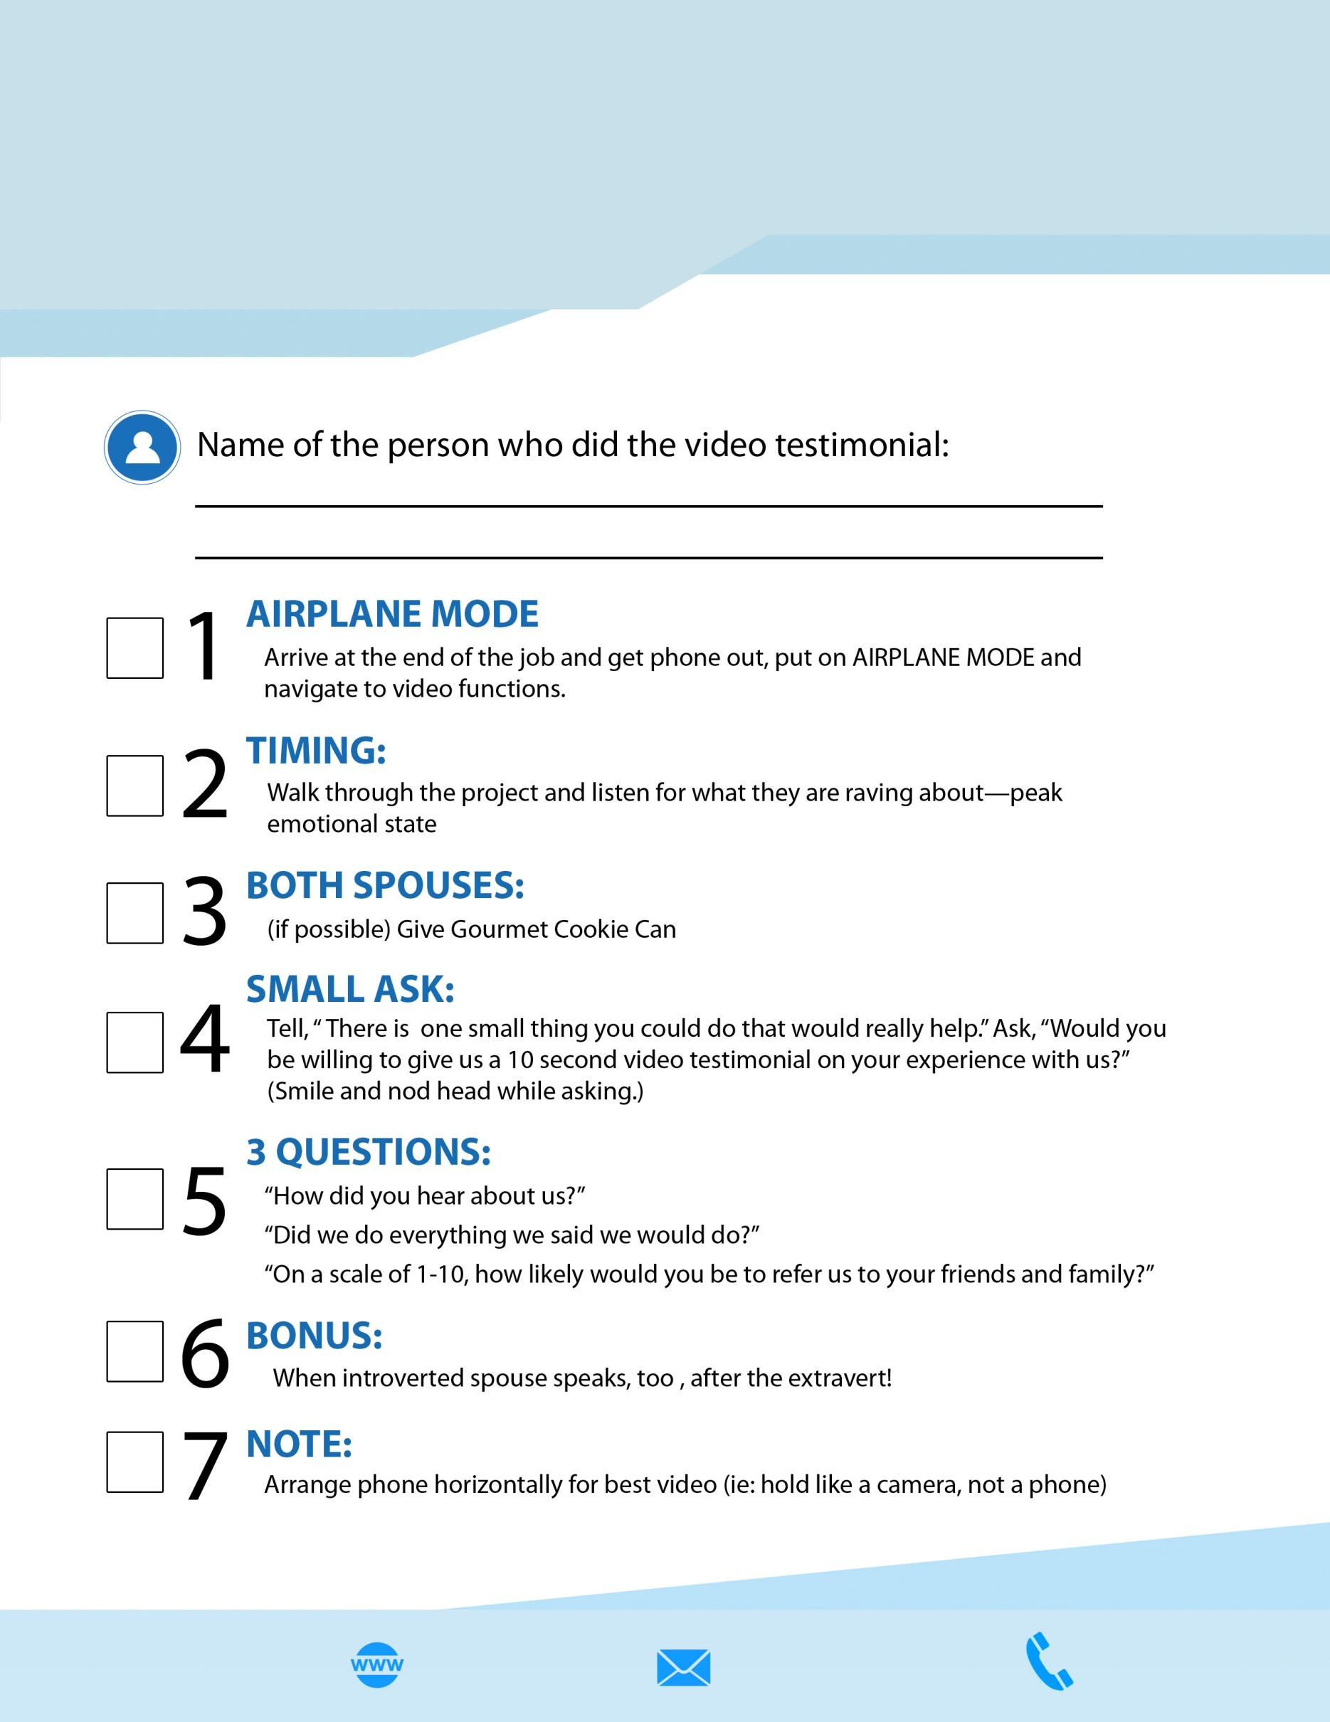

**Video Testimonial Checklist  
COMPANY** NAME

email@CompanyName.com

**Company Name**

CompanyName.com

+12 3 456 789

www.CompanyName.com

Logo